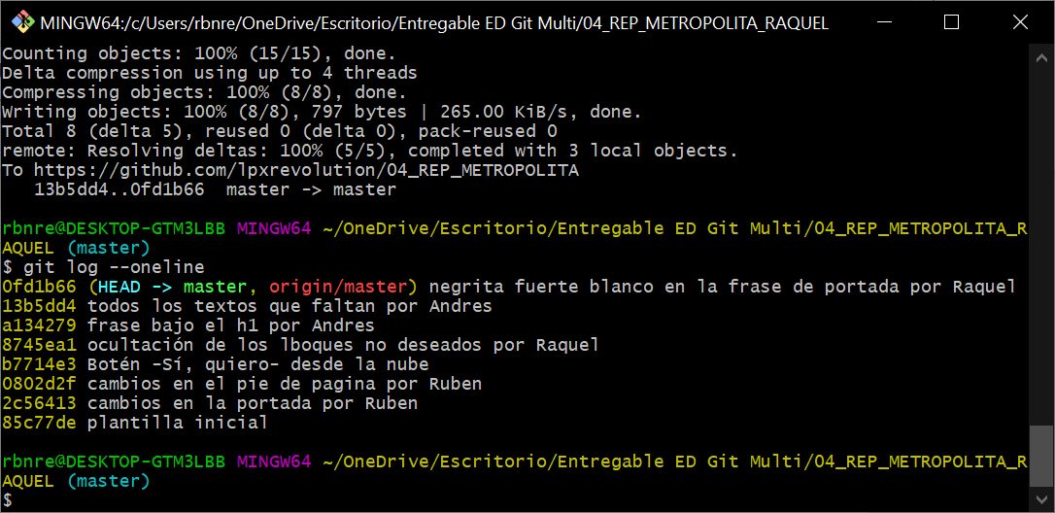

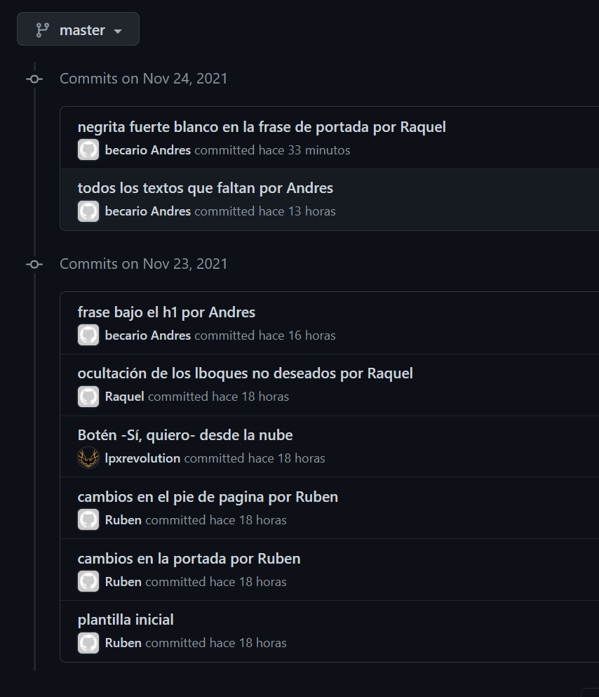

<https://metropolita-rubenlopez.netlify.app/>

https://github.com/lpxrevolution/04_REP_METROPOLITA/